WEEK 3:
PRODUCT & CUSTOMER ANALYSIS

TABLE OF CONTENT PAGE
1. BUSINESS OBJECTIVE 3
2. PART A: PRODUCT ANALYSIS 4
3. PART B: CUSTOMER ANALYSIS 9
4.KEY INSIGHTS 12
5. RECOMMENDATION 14
6. CONCLUSION 16

OBJECTIVE:
This analysis focuses on evaluating product and customer performance using the Superstore dataset. PostgreSQL was used to analyse sales, profit, quantity sold, product performance and customer purchasing behaviour. The analysis aims to identify top-performing and loss-making products, assess category and sub-category profitability, and understand customer value and purchasing patterns. The findings are intended to highlight business strengths, identify areas requiring improvement, and support data-driven decision-making to improve profitability and overall business performance.

PART A: PRODUCT ANALYSIS
This section evaluates product and sub-category performance based on sales, profit and quantity sold. The analysis aims to identify the products that contribute most to revenue and profit, as well as products and sub-categories that may require further attention.

Top 10 products by sales:
This analysis identifies the 10 products generating the highest total sales, highlighting the strongest revenue contributors in the product portfolio.
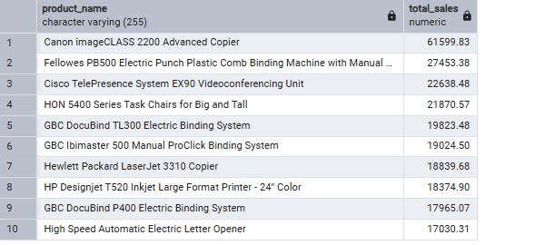

Top 10 products by profit:
This analysis identifies the 10 most profitable products, showing which products contribute most to the company's overall profit.
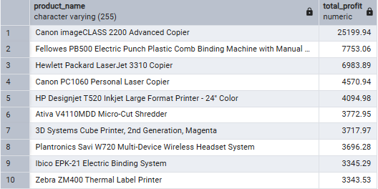

Bottom 10 Products by Profit
This analysis highlights the 10 products with the lowest total profit, including products that may be generating losses and therefore require further investigation.
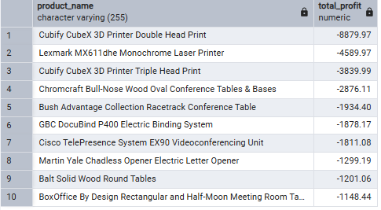

Sub-Category Analysis
This analysis compares sub-categories based on total sales, profit and quantity sold to understand which areas perform strongly and which may be underperforming. Profit margin is used alongside sales and profit to assess how efficiently each sub-category converts sales into profit. This helps distinguish high-sales sub-categories from genuinely profitable ones.

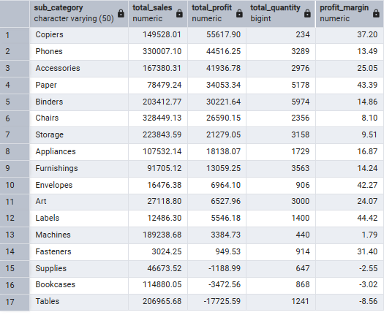

Number of loss-making products
This analysis determines how many individual products generate an overall negative profit, providing an indication of the scale of product-level losses.
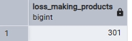

Loss-making sub-categories
This analysis identifies sub-categories where total profit is negative, helping determine whether losses are concentrated within particular areas of the product portfolio.
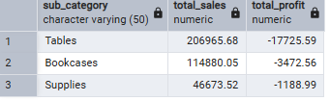

Most profitable sub-category
This identifies the sub-category generating the highest total profit, highlighting an important contributor to overall business profitability.
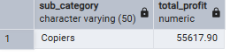

Most popular sub-category by quantity
This identifies the sub-category with the highest total quantity sold, providing insight into which product group has the greatest sales volume.;
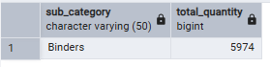

Insightful Questions:
1. Which product generates the most sales?
Finding:
Based on the PostgreSQL output, the Canon imageCLASS 2200 Advanced Copier generated the highest total sales, amounting to R61,599.83.
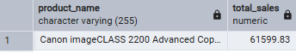
Business Insight:
This indicates that the Canon imageCLASS 2200 Advanced Copier is the strongest individual contributor to product revenue within the dataset.
2. Which product generates the most profit?
Finding:
The Canon imageCLASS 2200 Advanced Copier also generated the highest total profit, with a profit of R25,199.94.
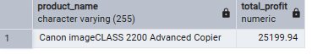
Business Insight:
The product is particularly valuable because it ranks highest in both sales and profit, making it an important contributor to overall business performance.
3. Which category performs best?
Finding:
The Technology category performed best overall, generating approximately R836,945.93 in sales and R145,454.95 in profit. It also recorded the highest profit margin among the three categories at approximately 17.37%.
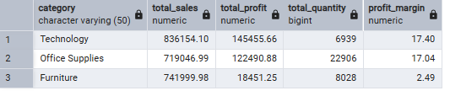
Business Insight:
Technology is the strongest-performing category because it leads in both revenue and profitability, making it an important area for continued focus and investment.
5. Which sub-category needs attention?
Finding:
Tables requires the most attention. It generated approximately R206,965.68 in sales but recorded a negative profit of R17,725.59, resulting in a negative profit margin of approximately -8.56%.
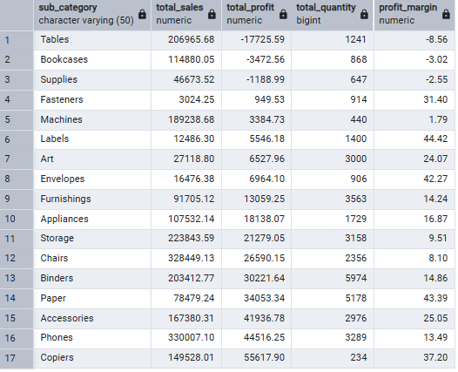
Business Insight:
Although Tables generates a substantial amount of sales, it is operating at a loss. This suggests that sales volume alone is not translating into profitability. The business should investigate discounting, pricing and operating/product costs within this sub-category.

PART B: CUSTOMER ANALYSIS
This section examines customer purchasing behaviour and profitability to understand customer value, order activity and their contribution to overall business performance.

Total customers
This analysis determines the total number of unique customers represented in the dataset
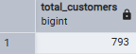

Top 10 customers by sales
This identifies the 10 customers generating the highest total sales, highlighting the customers who contribute most to revenue.

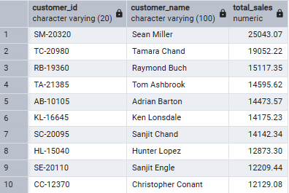
Top 10 profit by customer
This identifies the 10 customers generating the highest total profit, showing which customers provide the greatest profitability to the business.
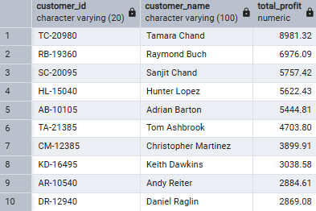

Top 10 Least Profitable Customers
This analysis identifies customers generating the lowest profit, including customers who may generate negative profit and therefore require further investigation.

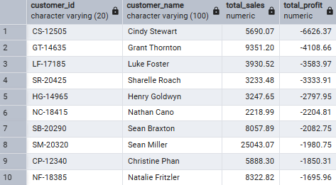

Top 10 customers by number of orders
This identifies the 10 customers with the highest number of orders, highlighting customers with the strongest purchasing frequency and potential customer loyalty.
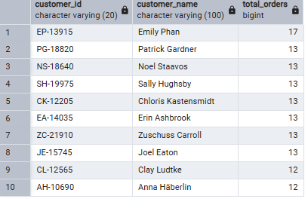

Customer Segmentation
Customers are grouped according to their purchasing value and profitability to distinguish high, medium and low-value customers. This provides a clearer view of customer contribution and can support targeted customer strategies
PLEASE REFER TO THE EXCEL FILE. CLICK HERE TO VIEW CUSTOMER SEGMENTATION.

KEY BUSINESS INSIGHTS
The product and customer analysis revealed several important patterns regarding revenue generation, profitability and areas requiring business attention.

1. Canon imageCLASS 2200 Advanced Copier is a key product
- The Canon imageCLASS 2200 Advanced Copier generated the highest sales at R61,599.83 and also generated the highest profit at R25,199.94. This indicates that the product is not only a strong revenue generator but also contributes significantly to profitability.
2. Technology is the strongest-performing category
- The Technology category performed best overall, generating the highest sales and profit among the three categories. This suggests that Technology is an important contributor to the overall financial performance of the business.
3. A significant number of products are loss-making
- The analysis identified 301 products generating negative profit. This indicates that although the business generates sales across a wide range of products, not all products contribute positively to profitability. These products represent an opportunity for the business to investigate the causes of the losses.
4. Tables is a key area of concern
- The Tables sub-category requires particular attention because it generates sales but operates at a loss. This demonstrates that high sales do not necessarily translate into profitability and highlights the importance of monitoring margins at sub-category level.
5. Profitability differs substantially across sub-categories
- The analysis shows that some sub-categories make a strong contribution to profit while others perform poorly. Copiers emerged as the most profitable sub-category, while loss-making areas require further investigation. This demonstrates why analysing profit alongside sales and quantity is important when evaluating product performance.
6. Sales volume and profitability are not always aligned
- The most popular sub-category based on quantity sold is not necessarily the most profitable. This highlights an important business distinction between product demand and financial performance. High sales volume should therefore be evaluated together with profit and profit margin rather than being used as the sole measure of success.

7. Customer behaviour is an important part of overall performance
- The customer analysis evaluated customer sales, profitability, purchasing frequency and customer segmentation. This provides the business with a basis for identifying high-value customers, frequently purchasing customers and customers whose activity contributes less positively to profitability.

RECOMMENDATIONS
Based on the findings above, the following actions are recommended:

1. Maintain and promote high-performing products
- Products such as the Canon imageCLASS 2200 Advanced Copier, which perform strongly in both sales and profit, should be monitored and prioritised in sales and marketing strategies. The business should also identify other products with similar profitability characteristics.
2. Investigate the causes of product-level losses
- The 301 loss-making products should be reviewed to determine whether their losses are associated with high discounts, low selling prices, product costs or weak demand. Products that consistently generate losses should be considered for repricing, renegotiation of costs or removal from the product portfolio.
3. Review the Tables sub-category
- The Tables sub-category should receive specific attention because it generates sales while operating at a loss. Management should investigate its pricing, discount levels, acquisition costs and individual product performance before deciding whether changes to the product range are necessary.
4. Focus on profitable growth within Technology
- Since Technology is the strongest-performing category, the business should continue investing in products within this category while monitoring whether growth is accompanied by healthy profit margins.
5. Use profit margin alongside sales volume
- Business decisions should not be based solely on sales or quantity sold. Profit and profit margin should be considered alongside sales volume to ensure that high-demand products are also financially sustainable.
6. Develop targeted customer strategies
- The customer analysis can be used to distinguish high-value, medium-value and low-value customers. High-value customers should be prioritised through retention strategies, while lower-value or less profitable customers can be targeted with appropriate offers designed to increase their value without unnecessarily reducing margins.
7. Monitor customer profitability
- Customers generating high sales but relatively low or negative profit should be investigated further. The business should assess whether discounts, order characteristics or servicing costs are reducing profitability and adjust its customer strategy accordingly.

Overall, the analysis shows that strong sales performance does not always translate into strong profitability. By focusing on profitable products, addressing loss-making areas and using customer-level insights to guide decision-making, the business can improve both revenue quality and overall profitability.

Conclusion
This analysis provided valuable insights into the product and customer performance of the Superstore dataset. The results show that while some products and categories contribute strongly to sales and profit, others generate low or negative profitability. The Canon imageCLASS 2200 Advanced Copier was identified as a leading product in both sales and profit, while Technology was the strongest-performing category overall. At the same time, the analysis highlighted areas of concern, particularly the Tables sub-category and the number of loss-making products.
The customer analysis further provided insight into purchasing behaviour, profitability and customer value, helping to identify differences between high- and lower-value customers. Overall, the findings demonstrate that high sales do not always translate into high profitability. By focusing on profitable products, addressing loss-making areas, reviewing pricing and discounts, and using customer-level insights to guide decisions, the business can improve profitability while maintaining strong sales performance.

